DLD LAB 10

24K-3055

Malik Zaryab.Awan

Bse-2A

Q1:

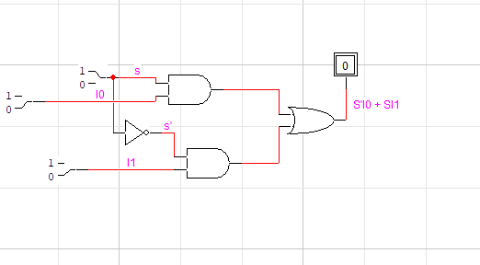

TruthTable:

|  |  |  |  |
| --- | --- | --- | --- |
| S | I0 | I1 | Output |
| 0 | 0 | 0 | 0 |
| 0 | 0 | 1 | 0 |
| 0 | 1 | 0 | 1 |
| 0 | 1 | 1 | 1 |
| 1 | 0 | 0 | 0 |
| 1 | 0 | 1 | 1 |
| 1 | 1 | 0 | 0 |
| 1 | 1 | 1 | 1 |

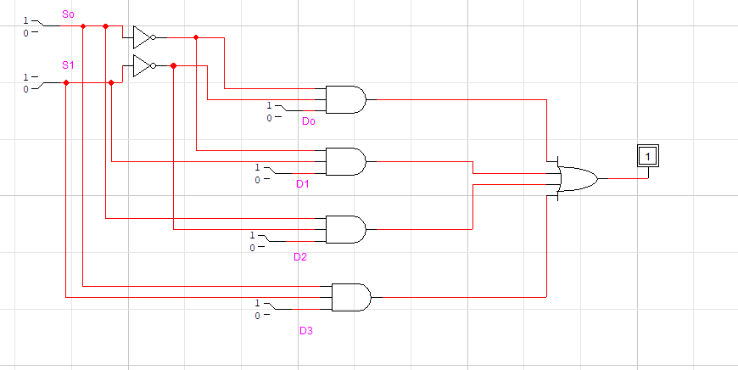

Truthtable:

|  |  |  |
| --- | --- | --- |
| S0 | S1 | Y |
| 0 | 0 | i0 |
| 0 | 1 | i1 |
| 1 | 0 | i2 |
| 1 | 1 | i3 |

Q2:

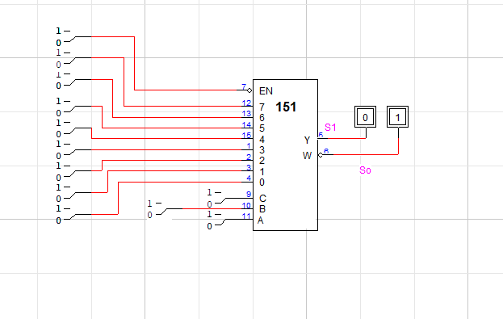

Q3:

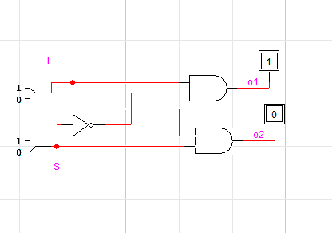

TruthTable: (1-2)

|  |  |  |  |  |  |  |
| --- | --- | --- | --- | --- | --- | --- |
|  |  | I |  | S | o0 | o1 |
|  |  | 0 |  | 0 | 1 | 0 |
|  |  | 1 |  | 1 | 0 | 1 |

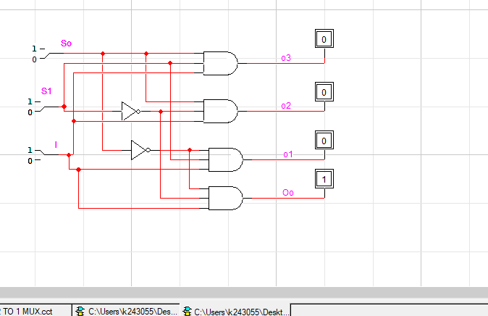

Truthtable: (1-4)

|  |  |  |  |  |  |  |
| --- | --- | --- | --- | --- | --- | --- |
| I | S0 | S1 | o0 | o1 | o2 | o3 |
| 1 | 0 | 0 | 1 | 0 | 0 | 0 |
| 1 | 0 | 1 | 0 | 1 | 0 | 0 |
| 1 | 1 | 0 | 0 | 0 | 1 | 0 |
| 1 | 1 | 1 | 0 | 0 | 0 | 1 |

Q4:

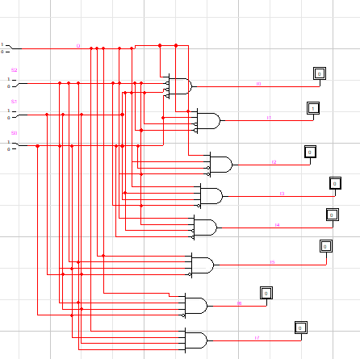

Q5:

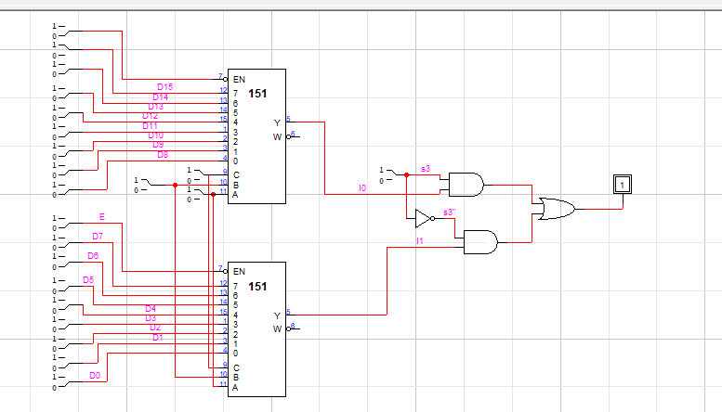

Q6:

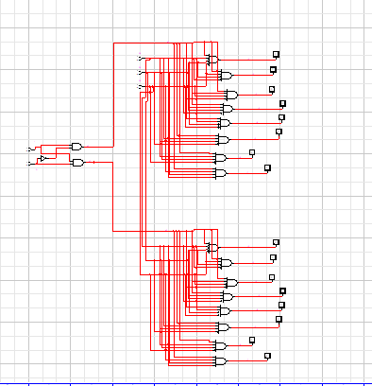

Q7:

